# Units 1-8: The Writing Process Unit 1 Gathering Ideas and Developing Focus

**Getting Taking Organising Linking ideas notes ideas ideas**

**Referencing Academic**

**style**

**Writing**

**Revising a final draft**

**The writing process**

## Session 1

*In this session you will learn how to do the following:*

* Identify some of the features of academic writing

**Activity 1: Introduction to academic writing**

*Work in groups.*

1. *Discuss the following questions:*
   1. What do you find easy / difficult about writing in English?
   2. What do you currently write in English? E.g. email, class notes.
   3. This module is all about essay and report writing. Have you ever written an essay or report in English? What was the topic and purpose?

*Writing essays and reports requires a special type of writing: academic writing. Let’s start by thinking about the questions:*

* What is academic writing?
* How is it different from other types of writing?

1. *Work in pairs. Complete the quiz to find out how much you know about academic writing. Tick (√) the correct answers.*
   1. When I write an essay or report I must…
      * write in a friendly style
      * copy some information from books / the Internet

* give references* to support my ideas
* write a lot
* use difficult and technical words
* organise my ideas in a special framework / structure*
  1. When I write an essay or report, I can use the following to support my ideas:
* research data
* views and attitudes of others
* information from the Internet
* information from books, articles and reports
  1. When I use other people’s ideas in my writing, I…
* can copy down their words
* put their ideas within quotation marks
* put their ideas in my own words
* must acknowledge that it is somebody else’s idea
  1. Academic writing should be…
* subjective*
* objective*
* precise*
* elaborate
  1. If I want to be successful in my academic writing, I also need to develop my critical thinking* and critical analysis* skills.
* True
* False

1. *Now read the definition given below and highlight the key information to check your answers from the quiz.*

An academic text is written for academic purposes such as teaching, learning, testing, seminars and conferences. It is written for academic audiences such as course teachers, peers, examiners, supervisors and academics. Academic writing is objective and impersonal. It is written in a formal style and uses academic vocabulary*. Its structures are complex, but not complicated, and are easy to follow. Academic writing expresses ideas clearly and precisely. The elements are logically connected and well structured. Academic writing requires extensive reading and critical thinking. Good academic writers express themselves coherently using cautious language. Academic writers support their ideas and opinions with research data and references to authoritative works within the same field, using a standard style of referencing.

## Activity 2: Elements to consider when getting started

Before you begin a writing task, there are several elements* you need to consider such as reader, purpose, context and length / style / type of writing.

1. *Work in pairs. Match each element in the star with the correct speech bubble.*



1

Who am I writing for: My teacher? Friends? The general public? An examiner?

2

Why am I writing? Is it to: Inform? Report? Persuade?

Describe?

Evaluate? Narrate?

**reader**

**context**

**writi**

**ng**

**purpose**

3

Is this:

A classroom task? An exam task? A home task?

4

How many words or pages do I need to write? In what format / type / style?

**length style type**

1. *Discuss in groups.*
   1. *Why are these elements important?*
   2. *Which do you think are the most important ones and why?*
   3. *Which of these elements do you think about when you start a writing task?*

## Activity 3: Types of academic texts

Here are some of the types of academic texts which you may read or write as part of your university studies:

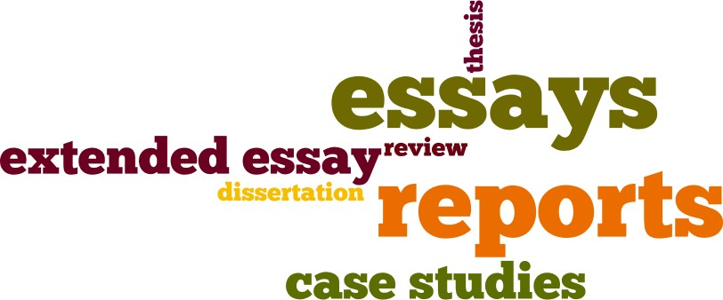

*Discuss in pairs: Which of these do you know about? Use the words above to fill in the gaps:*

* 1. In most subjects you have to write . In these you develop an argument while discussing and analysing a topic giving facts and opinions.
  2. provide an analytical study of a practice, scenario or situation and its development at a point of time or over a period of time. They are often used in subjects such as business, medicine and law.
  3. In many subjects you have to write . These are detailed accounts giving factual information and data which the writer has collected about a specific topic for a specific purpose. Science, engineering and business subjects often use these.
  4. In your subject you may need to write a . This is a critical assessment by the writer of an author’s ideas and arguments.
  5. An develops an argument while discussing and analysing a specific topic in detail. It is usually longer than an ordinary essay and is often used in project work or for assessment purposes.
  6. Later on in your studies you may have to write a . This is a longer piece of writing that develops an argument while discussing and analysing a topic and which contains the writer’s own ideas and research. This is often written as part of the requirements of a higher degree.
  7. A is an extra-long piece of writing (usually more than 50,000 words!) that discusses and analyses a specialised topic in great depth and which is based on the writer’s original research. This is often written over several years as part of a higher degree like a PhD.

## Activity 4: The purpose of academic writing

1. *It’s also important to think about the purpose of your writing. Now match the purpose with the task. How many of these purposes are you familiar with? Share your response with the rest of the class.*

|  |  |  |
| --- | --- | --- |
| **Academic Essay Purpose** | | |
| ***Purpose*** |  | ***What is to do*** |
| **Process** | *1* | telling a story |
| **Compare and contrast** | *2* | exemplifying the meaning of certain words, phrases or ideas |
| **Description** | *3* | relating to your perception; what you see, feel,  smell, taste and hear |
| **Explanation** | *4* | giving arguments in favour of or against a  proposition |
| **Narration** | *5* | describing a progression of events or ideas |
| **Argument** | *6* | grouping things or ideas into categories |
| **Cause and**  **effect** | *7* | illustrating similarities and/or dissimilarities  between concepts |
| **Problem-**  **solving** | *8* | analysing why something happened and how it  led to a result |
| **Classification**  **and Division** | *9* | examining ideas, events and topic and clarifying  them |
| **Definition** | *10* | addressing a problem which is worth pursuing  and for which a practical solution can be sought |

These purposes can be used and combined in many types of academic writing such as essays, reports and reviews. We will be looking at some of these purposes in more detail in later units.

1. *Read the following essay titles below. What do you think is the purpose of these essays? Write your responses and share with a partner.*

|  |  |
| --- | --- |
| **Essay title** | **Purpose** |
| Why do Bangladeshi parents prefer costly English- medium schools? | **Explanation** |
| Part-time job opportunities for students: Exploring  the options |  |
| ‘Lack of political stability is the only impediment to the economic development of Bangladesh’ – Do you agree? |  |

|  |  |
| --- | --- |
| Education facilities of public and private  universities in Bangladesh |  |
| Living in Dhaka city |  |
| Why is the young generation less interested in reading books? How can reading habits be  increased? |  |
| The most memorable trip of my life |  |
| High dropout rate is a major problem in rural Bangladesh. How do you think the present  situation can be improved? |  |

## Extension: Types of academic writing

*Find out which types of academic writing are most common for your major course*. *Make a list.*

My subject:

|  |  |  |
| --- | --- | --- |
| In my classroom | In my examinations | For my home work |
|  |  | [*e.g. essay*] |
|  |  |  |
|  |  |  |

## Home task

1. Portfolio task

  *Imagine that one of your class friends was sick today and missed the first session. Write an email explaining to him/her in your own words:*

* 1. What you have found out today about academic writing and about the module.
  2. What four elements he/she needs to take into account when starting a writing task and why.

*Add your completed task to your portfolio.*

# Unit 1 Gathering Ideas and Developing Focus

**Getting Taking Organising Linking ideas notes ideas ideas**

**Referencing Academic**

**style**

**Writing**

**Revising a final draft**

**The writing process**

## Session 2

*In this session you will learn how to do the following:*

* Generate ideas for a writing task
* Narrow down a topic and develop a focus

**Activity 1: Generating ideas for a writing task – brainstorming**

Brainstorming ideas is one of the first stages of the process that leads to an essay or a report.

* + 1. *Check your understanding of what* ***brainstorming*** *means by putting the words of the box in the correct order in the space given.*

as you can

on a page.

in any order

as many different ideas

about a topic

~~quickly think of~~

and write them

**Brainstorming is when you**

quickly think of

* + 1. *Read the following paragraph* to find out how brainstorming could help you in writing your essays and reports. Then answer the questions that follow.*

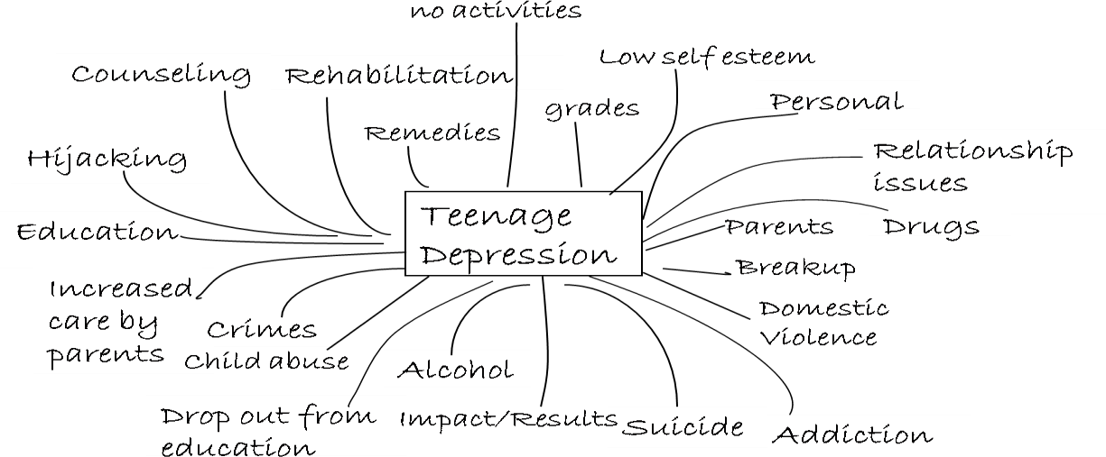

Brainstorming* is when you quickly think of as many different ideas as you can about a topic and write them down in any order on a page. This will help you to gather the biggest range of ideas to choose from to complete your writing task. You can brainstorm alone or in a group. Brainstorming in a group can be very effective as you can get ideas from each other and you will often generate new ideas by working together. While brainstorming, think about everything you know about the topic. This could include key facts, quotes, data, people / ideas connected to the topic, background information, current debate and ideas, things you’ve read in books or on the Internet or heard about in the news or from your friends or teacher. Write them all down quickly in the form of notes. In your notes you can use abbreviations, symbols, single words or short phrases, numbers, questions, pictures. Your notes don’t have to be neat and tidy and they don’t have to be written in long sentences or in correct English. A brainstorming sheet may look something like this:

* + 1. *Now discuss in pairs:*
       1. What sort of information should you note down as you **brainstorm**?
       2. How should you write your notes as you **brainstorm**?
       3. Why is it helpful to **brainstorm** in a group?
    2. *Look again at the brainstorming example in the text (Teenage Depression). Can you add any more ideas? Which of the ideas do you think are the most common causes of teenage depression?*

*Share your responses with the rest of the class.*

## Activity 2: Brainstorming for an essay

*Work in small groups.*

*Choose one of the following titles (1-4) that interests you. Choose carefully as you will be developing an essay on your title choice over the next few units.*

* + - 1. Discuss the impact of global warming on climate change in Bangladesh.
      2. Pleasure and misery of winter in Bangladesh.
      3. Analyse the causes and remedies of school students’ drop out in Bangladesh.
      4. Evaluate what makes a good learner.

*Brainstorm all the relevant ideas that come to your mind about the topic. Remember to write them down as words, phrases, statements, symbols, or numbers, and not as complete sentences. Write your brainstorming notes below.*

My essay title:

## Activity 3: How to narrow down a topic and develop a focus

*Work in pairs.*

1. 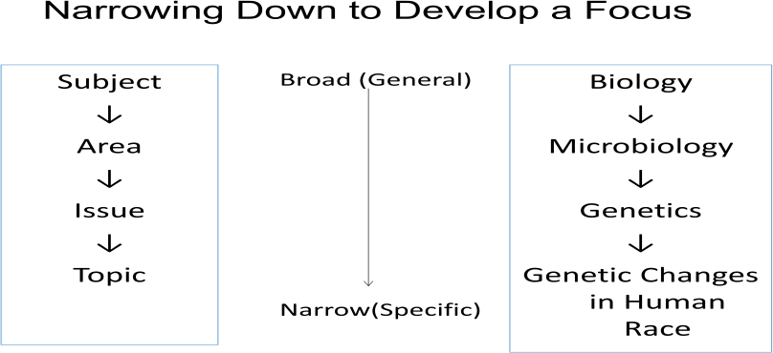*Along with brainstorming you need to think of a suitable topic for your essay. For this, you need to follow some specific steps to get a topic from some interesting issues in your subject. Look at the flow chart to find out how.*
2. A student, Abid, has a question:

I have to write an extended essay on gender discrimination – how do I choose a good topic?

*Put the topics in order from most general to most specific to help Abid find a suitable topic for his assignment.*

Most general

e

1. Gender discrimination in higher education in Bangladesh
2. Causes and effects of gender discrimination in the private job sector in Bangladesh
3. Causes and effects of gender discrimination in Bangladesh
4. Impact of gender discrimination
5. Gender discrimination

**Study tip**

You need to narrow down an issue to a specific topic which can be discussed convincingly. It should not be too general or too specific because in both cases you may find it difficult to decide which ideas to gather.

Most specific

*Discuss in pairs: Which would be the most suitable topic for Abid’s essay?*

## Activity 4: Using questions to develop a focus

*Work in pairs.*

You can develop the focus for your essay / report topic through asking yourself some questions. First, write down as many *wh*-questions* as possible. Then, decide which one is the most suitable topic for your essay/report by thinking about the length / style / type, purpose, context and reader.

* 1. *You are assigned to write an essay on the topic Teenage Depression. Your classmate, Mithila, has framed some questions to develop a focus. Can you add some more?*
     1. What is teenage depression?
     2. What are the different forms of teenage depression?
     3. What are the causes of teenage depression?

4. _?

5. _?

6. _?

7. ?

8. ?

* 1. *Imagine you are supposed to submit a take-home assignment on Disaster Management next week. Your course teacher instructs you that the assignment should not exceed 300 words. Now, do the following task to develop focus and decide your topic.*

**Disaster Management**

* Generate as many *wh*- questions as you can about the issue.
* Decide which would be the most suitable topic for the assignment.

## Extension: General or specific?

1. *Are the following general issues or specific topics? Justify your choice with a short explanation for each.*

|  |  |  |  |
| --- | --- | --- | --- |
|  | General | Specific | Explanation |
| An analysis of the impact of co-education |  |  |  |
| Child trafficking |  |  |  |
| Causes of political violence in Bangladesh |  |  |  |
| The importance of jogging |  |  |  |
| Good governance |  |  |  |

1. *The following are some issues. Generate a topic for each of them.*
   1. Satellite Television Channels
   2. Women’s Empowerment

*Share your ideas with your partner*

## Home task

* + 1. Critical reflection

*Think back on what you have learnt in this unit and reflect on the experience.*

* + - 1. What have you learnt about how to get started on a writing task?
      2. What have you learnt about brainstorming?
      3. What have you learnt about developing the focus of a topic?
    1. Portfolio task

*Fill out the table below to show that you can create specific topics in your subject area.*

Example:

: Sociology

: Social Problems

: Youth crime

*:* What are the causes of youth crime?

: Analysis of social issues

: Causes of youth crime in urban societies

Subject

Area Issue Question Purpose Topic

Task:

:

:

:

:

:

:

Subject

Area Issue Question Purpose

Topic

*Add your completed task to your portfolio.*

* + 1. New vocabulary

*Use your dictionary to search the meaning of the following words which you have found in this unit and will encounter in the next unit. Write the meanings in the meaning column of the table.*

*Unit 1*

|  |  |
| --- | --- |
| *Words* | *Meaning* |
| coherently |  |
| impediment |  |
| peers |  |
| perception |  |
| persuade |  |
| portfolio |  |
| precise |  |
| proposition |  |
| pursuing |  |
| scenario |  |
| subjective |  |

*Unit 2*

|  |  |
| --- | --- |
| *Words* | *Meaning* |
| apprenticed |  |
| craftsman |  |
| deluged |  |
| elucidate |  |
| execution |  |
| futuristic |  |
| infrastructure |  |
| intricate |  |
| marooned |  |
| motifs |  |
| phenomenon |  |